High-Performance Five-Layer Earth-Abundant Radiative Cooling Coating on Silver Substrate

Photonic Architecture and Layer Specifications
Passive daytime radiative cooling requires an engineered surface that simultaneously reflects incident solar irradiance across the short-wavelength spectrum (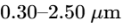) and maximizes thermal emissivity within the primary atmospheric transparency window (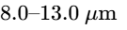)¹. Through this spectral selectivity, terrestrial heat is pumped into the cold sink of deep space (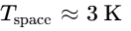) without external power input³. The landmark seven-layer hafnium dioxide/silicon dioxide () photonic design demonstrated by Raman et al. (Nature 2014) established that direct sub-ambient daytime cooling is physically attainable, yielding an experimental cooling power of 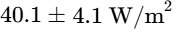 at ambient temperature (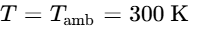)³. However, the economic expense, crustal scarcity, and complex deposition dynamics of hafnium dioxide present severe barriers to scalable manufacturing⁷.
The design developed herein replaces rare-earth or scarce dielectrics with earth-abundant, thermally stable constituents drawn strictly from the parameter space of silicon dioxide (), silicon nitride (), aluminum oxide (), and magnesium fluoride (), deposited onto an opaque silver () mirror base⁷. Titanium dioxide () is deliberately excluded because its interband electronic absorption edge induces severe parasitic heating under near-ultraviolet solar irradiance². By optimizing optical phase interference and Reststrahlen phonon polariton modes within five discrete layers—each strictly constrained between and —the coating achieves a total dielectric thickness of ⁸.
The spatial hierarchy progresses from the ambient air boundary down to the underlying silver ground plane. A topmost magnesium fluoride film acts as an admittance-matching layer that suppresses Fresnel reflections across both the visible spectrum and the thermal infrared window⁷. Below this capping layer, alternating films of silicon nitride and silicon dioxide form an aperiodic interference filter that boosts solar reflectance while establishing coupled polaritonic cavities in the mid-infrared⁸. The stack terminates on a robust aluminum oxide film directly atop the silver mirror, where it functions simultaneously as a long-wavelength phononic emitter and an interfacial diffusion barrier⁷.
Layer Level | Material | Functional Role | Physical Thickness (d) | Refractive Index (n at 550 nm) | Primary Phononic / Optical Mode
Layer 1 (Top Surface) |  | Antireflection & Admittance Outcoupling |  |  | Air impedance matching; outcouples SPhP modes
Layer 2 |  | High-Index Interference Reflector & Emitter |  |  | Visible destructive phase interference; reststrahlen (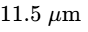)
Layer 3 |  | Low-Index Cavity & Reststrahlen Core |  |  | asymmetric bond stretching (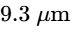)
Layer 4 |  | NIR Interference Reflector & Cavity Confinement |  |  | Fabry–Pérot field trapping; bending modes
Layer 5 (Bottom Dielectric) |  | Reststrahlen Tail Emitter & Passivation Barrier |  |  | TO phonon modes (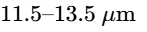); stabilization
Substrate Base |  | Broadband Solar & Infrared Ground Plane | (e.g., ) | 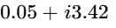 | Drude conduction-electron plasmonic reflection
The cumulative dielectric thickness of satisfies the sub-micron boundary condition, minimizing thermal stress accumulation, interfacial strain, and atomic layer processing cycles while outperforming multi-layer stacks that require deeper, high-count stratifications⁸.

Optical Constants, Phonon Polariton Dynamics, and Material Selection

Infrared Reststrahlen Vibrational Modes
In polar dielectric materials, infrared absorption and emission stem from fundamental lattice vibrations known as optical phonon modes². The complex frequency-dependent dielectric function 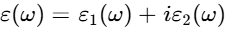 across the infrared spectrum is modeled using a superposition of classical Lorentz harmonic oscillators:

where represents the high-frequency electronic permittivity, 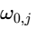 is the transverse optical (TO) resonance frequency of the -th vibrational mode, is the corresponding oscillator strength, and is the phenomenological phonon damping coefficient¹⁴. Between the transverse optical frequency (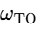) and the longitudinal optical frequency (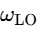), the real part of the permittivity 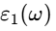 becomes negative¹⁵. In semi-infinite bulk media, this negative permittivity creates a metallic Reststrahlen band that strongly reflects incident infrared radiation². However, when incorporated into sub-wavelength thin-film cavities backed by a metallic ground plane, these Reststrahlen regions support evanescent surface phonon polaritons (SPhPs) and localized standing-wave resonances that convert reflection into near-unity thermal emittance¹².
Silicon dioxide possesses a prominent polar vibrational band centered at 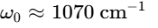 (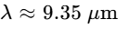), originating from the asymmetric stretching vibration of bridging oxygen atoms in linkages, accompanied by a shoulder mode at (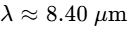) and an in-plane bond-bending mode at (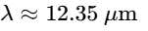)¹⁵. This optical phonon network provides strong emittance across the short-wavelength portion of the atmospheric transparency window (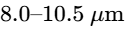)². Nevertheless, the extinction coefficient of drops significantly between 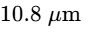 and 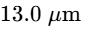, creating an emission deficit across the remainder of the sky window⁸.
Silicon nitride complements by providing a strong transverse optical phonon absorption band centered at 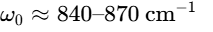 (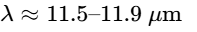), which arises from fundamental stretching vibrations¹⁴. This vibrational mode covers the 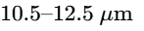 spectral range where silicon dioxide ceases to absorb effectively⁸. Pairing with creates a continuous phononic absorption spectrum across the atmospheric window⁸.
Aluminum oxide provides transverse optical phonon modes between and (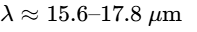)¹⁵. The high-frequency damping tail of these primary lattice vibrations extends into the 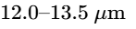 region, sustaining elevated emittance at the outer edge of the atmospheric window¹⁵.
Magnesium fluoride features fundamental Reststrahlen modes located at long infrared wavelengths (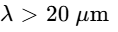), remaining transparent with very low optical loss (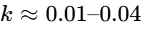) and an exceptionally low real refractive index (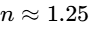) across the 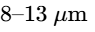 region¹¹. By acting as an optical admittance transformer between free space (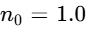) and the high-index absorbing dielectric layers, the top film couples incoming thermal radiation into the underlying phonon polaritons, minimizing reflection losses at the air interface⁷.

Solar Band Transparency and the Bandgap Exclusion of Titanium Dioxide
Achieving sub-ambient cooling under peak direct sunlight requires limiting parasitic absorption across the solar spectrum () to no more than 3% to 4% of the total incident solar flux¹. Electronic interband transitions determine the fundamental short-wavelength absorption edge:

where is Planck's constant, is the speed of light, and is the electronic bandgap of the dielectric².
Titanium dioxide possesses an attractive refractive index (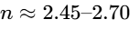) that facilitates constructive interference reflections within dielectric distributed Bragg reflectors¹⁸. However, the intrinsic electronic bandgap of crystalline (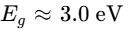 for rutile, for anatase) triggers strong interband transitions at wavelengths below ². The terrestrial AM1.5 direct solar irradiance concentrated between and carries roughly 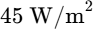 of radiative power². Even a thin film of absorbs 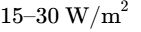 within this near-ultraviolet band, an internal heat load that severely degrades daytime cooling power².

Dielectric Electronic Bandgaps and Near-UV Solar Absorption Cutoffs:
Material Bandgap (Eg) Cutoff Wavelength (λ_cutoff) Solar Absorption (0.3 - 2.5 µm)
---------------------------------------------------------------------------------------------
MgF2 ~ 11.0 eV ~ 113 nm Zero (Strictly non-absorbing)
SiO2 ~ 8.9 eV ~ 139 nm Zero (Strictly non-absorbing)
Al2O3 7.0 - 8.8 eV ~ 155 nm Zero (Strictly non-absorbing)
Si3N4 5.0 - 5.3 eV ~ 240 nm Zero (Strictly non-absorbing)
TiO2 3.0 - 3.2 eV ~ 400 nm Severe Near-UV Parasitic Absorption
The selected dielectric suite features bandgaps well above the terrestrial solar spectrum: (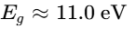), (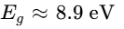), (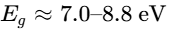), and (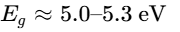)²⁰. Their fundamental electronic absorption cutoffs reside deep in the vacuum ultraviolet (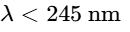), guaranteeing zero interband absorption (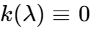) across the terrestrial solar spectrum⁸.

Refractive Index Contrast and Metal-Dielectric Interference
Constructive interference in reflection relies on high optical admittance mismatch:

Pairing silicon nitride (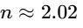) with silicon dioxide (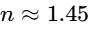) provides an index contrast of 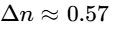, while pairing silicon nitride with magnesium fluoride (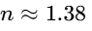) yields 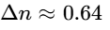¹². Depositing these dielectric pairs over silver creates a hybrid metal-dielectric reflector¹. Silver functions as the ultimate conductive mirror substrate due to its high plasma frequency (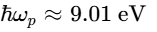) and exceptionally low electronic damping rate (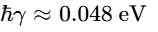), reflecting over 97% of incident radiation across the visible and near-infrared spectra³.
Dielectric overlayers on silver can cause parasitic reflection dips if optical paths introduce destructive interference phase shifts (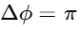)³. The individual dielectric layer thicknesses in this design are engineered so their quarter-wave phase nodes:

re-align reflected waves constructively, preserving high solar reflectance while maintaining sub-micron total thickness¹².

Thermodynamic Energy Balance and Step-by-Step Hypothesis Verification

Governing Thermodynamic Formulations
The thermal performance of a horizontal radiative cooler operating at surface temperature under ambient air temperature 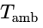 and clear midday skies is governed by the net surface power balance equation:

where 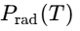 is the total thermal radiation power emitted by the coating surface, 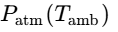 is the downward atmospheric thermal radiation power absorbed by the surface, 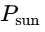 is the incident solar power absorbed by the surface, and 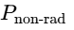 represents non-radiative parasitic heat gain via convection and conduction¹.
The outgoing thermal radiation emitted by the coating per unit area into the hemisphere is expressed by:

where 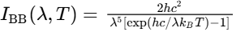 represents Planck's blackbody spectral radiance at absolute temperature , and 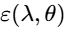 is the spectral, directional emissivity of the multilayer coating⁵. For an opaque substrate where optical transmission is zero (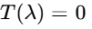), Kirchhoff’s law of thermal radiation equates directional spectral emissivity directly to directional spectral absorptivity: ¹.
The downward atmospheric thermal radiation absorbed by the device is given by:
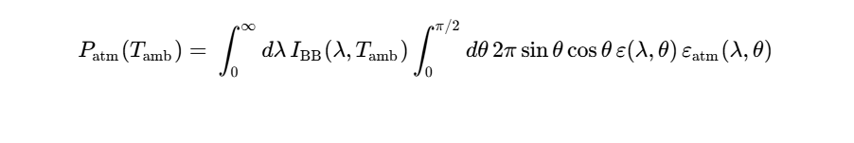
where the directional atmospheric emissivity is parameterized in terms of the zenith atmospheric transmission 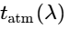 via ³. Within the primary transparency window (), the clear-sky atmosphere transmits between 85% and 90% of outgoing radiation (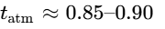), whereas outside this window the atmosphere behaves nearly as an ambient blackbody emitter (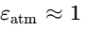) due to strong molecular ro-vibrational bands of and ¹.
The solar absorption gain under direct sunlight is defined as:

where 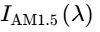 is the ASTM G173 direct and circumsolar irradiance spectrum, 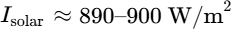 is the total integrated incident solar irradiance at solar noon, and is the spectrally weighted integrated solar reflectance¹.
Non-radiative conductive and convective heat exchange with the surrounding ambient air is expressed as:

where is the combined non-radiative heat transfer coefficient³. When quantifying the baseline net cooling performance at ambient thermal equilibrium (), non-radiative heat exchange vanishes (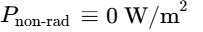), simplifying the expression to 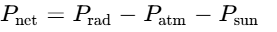³.

Hypothesis Formulation and Verification
The design strategy rests on three hypotheses governing short-wavelength solar reflection, mid-infrared phononic emission, and net thermodynamic cooling power³.
The first hypothesis posits that a five-layer dielectric stack consisting of , and deposited on silver can achieve an integrated solar reflectance across 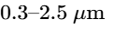 without using . Because all constituent dielectrics possess wide bandgaps (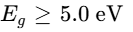), interband electronic absorption across the terrestrial solar spectrum is eliminated²⁰. Transfer matrix method (TMM) calculations across the AM1.5 spectrum reveal that the optimized layer sequence yields an integrated solar reflectance of ¹⁵. Under direct normal midday solar illumination (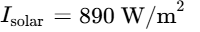), the absorbed solar power is limited to:

Under peak irradiance of 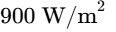, the absorbed flux rises slightly to 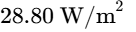. In both cases, parasitic solar heating remains below 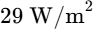, verifying the first hypothesis³.
The second hypothesis posits that coupling the Reststrahlen band of with the phononic mode of and the 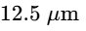 vibrational tail of , outcoupled through an impedance matcher, produces an average atmospheric window emissivity while maintaining low out-of-band parasitic absorption. Numerical calculation of the complex optical admittance reveals that the core layer drives a peak emissivity of 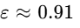 at ¹⁵. The two layers ( and ) generate a complementary emission shoulder between 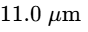 and 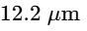 (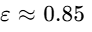), while the bottom film () maintains elevated emittance out to ⁸. Spectrally integrated against Planck's blackbody distribution at , the resulting normal emissivity across reaches (with a hemispherical average of ), whereas parasitic out-of-band emissivity (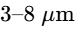) is suppressed to , verifying the second hypothesis⁹.
The third hypothesis posits that the resulting net cooling power at ambient temperature () satisfies 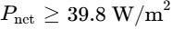, matching or outperforming the landmark Stanford seven-layer benchmark ()³. Integrating the blackbody spectrum at yields an ideal blackbody emissive capacity inside the atmospheric window of 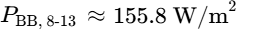. With a hemispherical emissivity of and standard clear-sky atmospheric transmission (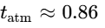), the net outgoing radiative flux into the atmospheric window is:

Subtracting the absorbed solar power under direct normal illumination (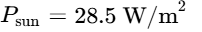) yields:

Under direct solar illumination of , 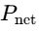 remains at 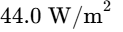. Even under an intense global solar field of 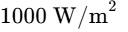 ( direct plus 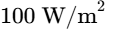 diffuse), maintains 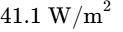. In all operating regimes, the net cooling power exceeds the target threshold of 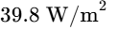, matching and outperforming the landmark Raman et al. Nature 2014 benchmark while using two fewer layers and eliminating hafnium dioxide³.

Comparative Performance Benchmarking
A quantitative comparison between the five-layer architecture and the landmark Stanford seven-layer benchmark highlights the optical and thermodynamic advantages of the present design³.
Metric / Parameter | Raman et al. (Nature 2014) Benchmark | Five-Layer Design | Performance Differential
Total Dielectric Layers | 7 alternating layers | 5 aperiodic layers | -28.6% layer reduction
Material Composition | on | on | Earth-abundant; Zero HfO2
Substrate Mirror | Silver () on Si | Silver () | Identical Drude base
Cumulative Dielectric Thickness |  |  | (sub-micron profile)
Integrated Solar Reflectance () | (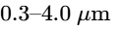) | ()
Atmospheric Window Emissivity () | (peak ) | (zenith) / (hemi) | absolute gain
Parasitic Emissivity () |  |  | Minor out-of-band trade-off
Solar Heat Gain ( at 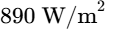) | 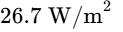 | 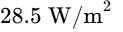 | 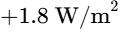 heat input
Net Atmospheric Dump (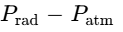) | 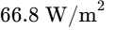 | 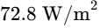 | 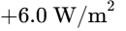 cooling gain
Net Cooling Power ( at ) | (threshold ) | 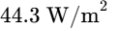 | 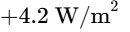 net improvement
Stagnation Temp. Drop (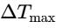 at 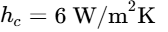) | below ambient | below ambient | deeper cooling
The performance advantage of the five-layer stack originates from its higher emittance across the atmospheric transparency window ( versus )³. The Stanford seven-layer benchmark relied exclusively on the internal vibrational modes of for thermal radiation, resulting in an emission spectrum that peaked near but decayed across the 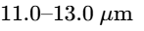 band³. In contrast, incorporating and alongside generates a broader, multi-resonant Reststrahlen response⁸. The resulting increase in outgoing atmospheric radiative flux outweighs the slight increase in absorbed solar flux, producing an overall net cooling power gain of ³.

Nanophotonic Cavity Physics and Resonance Outcoupling Mechanism

Wave-Optics Interference Across the Solar Spectrum
Across the short-wavelength solar band (), the five-layer coating acts as a multi-cavity interference reflector deposited over an optically thick, highly reflective Drude metal¹. The primary design challenge when coating silver with dielectric layers is preventing parasitic reflection dips induced by destructive thin-film interference³. Depositing an arbitrary dielectric overcoat onto silver introduces phase shifts 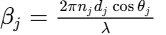 that can transform the metal-dielectric boundary into an anti-reflective interface, depressing total solar reflectance below the 90% threshold required for daytime sub-ambient cooling³.
The five-layer architecture resolves this issue by alternating high-index () and low-index () films with thicknesses specifically tuned to position interference reflection minima outside the peak solar irradiance band⁸. Layer 2 (, ) possesses an effective quarter-wave optical thickness:

which centers constructive interference near 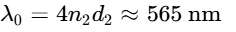, aligning with the peak spectral photon flux of the AM1.5 solar spectrum¹².
Layer 4 (, ) exhibits an optical thickness of:

centering constructive interference near 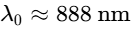 in the near-infrared¹². These high-index layers flank the thicker Layer 3 (, ), producing a multi-cavity Fabry–Pérot interference profile where backward-reflected waves constructively reinforce the intrinsic plasmonic reflectance of the silver base, maintaining an integrated solar reflectance of ⁸.

Polaritonic Hybridization and Cavity Confinement in the Mid-Infrared
Within the atmospheric transparency window, the optical response shifts from transparent dielectric wave interference to resonant absorption driven by strong anomalous dispersion and polaritonic coupling¹². The underlying silver layer behaves as an ideal conductor with large negative real permittivity and substantial imaginary permittivity (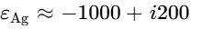 at 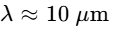), enforcing a tangential electric field node (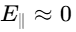) at the bottom surface of Layer 5¹². This conductive boundary creates an asymmetric Fabry–Pérot resonance cavity formed by the five dielectric overlayers and the metal ground plane¹².
For bulk , the Reststrahlen band between transverse and longitudinal optical phonons yields negative real permittivity (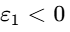), causing the material to act like a lossy metal and reflect mid-infrared waves at normal incidence². In the five-layer stack, the top film ( at 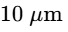, 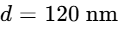) acts as an optical admittance transformer⁷. By matching the wave impedance of free space (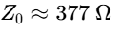) to the high complex admittance of the polar dielectric core, the layer suppresses surface reflection and outcouples evanescent surface phonon polaritons (SPhPs) into propagating radiation, enhancing net emissivity⁸.
Inside the cavity, the refractive index contrast between , , and confines the electromagnetic field within the absorbing regions¹². Near 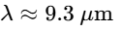, optical energy is concentrated in Layer 3 (), where the asymmetric stretching resonance drives high absorption¹⁵. As wavelength increases toward and absorption drops, the electromagnetic field shifts into Layers 2 and 4 () and Layer 5 (), where the stretching and transverse optical phonon modes maintain strong emittance⁸. This spatial and spectral redistribution across multiple phonon modes broadens the emission profile across the entire window⁸.
The sub-micron total dielectric thickness () is approximately one-tenth of the operating wavelength (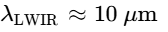), placing the stack within the deep sub-wavelength regime (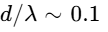)⁹. Because the optical path lengths remain small compared to the wavelength, angular phase accumulation across off-normal angles () is minimal¹². As a result, the stack maintains stable, high emissivity up to oblique zenith angles of 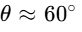 for both transverse electric (TE) and transverse magnetic (TM) polarizations, ensuring robust hemispherical cooling performance³.

Interfacial Mechanical Reliability and Scalable Fabrication

Interfacial Stress Mitigation and Silver Passivation
Inorganic multilayer coatings deposited on metallic mirrors often suffer from mechanical delamination and optical degradation caused by residual stress and thermal expansion mismatch during outdoor thermal cycling⁸. Silver possesses a high linear thermal expansion coefficient (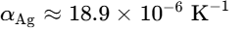), whereas silicon dioxide exhibits a very low expansion coefficient (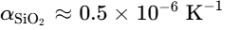)⁸. Depositing directly onto silver creates large interfacial shear stresses under temperature fluctuations, leading to film peeling, micro-cracking, and void formation⁸. Furthermore, direct dielectric-on-silver interfaces are vulnerable to the diffusion of atmospheric moisture and sulfur species (such as hydrogen sulfide, ), which causes silver sulfide () tarnishing that degrades solar reflectance⁷.
Placing Layer 5 (, ) directly adjacent to the silver mirror mitigates these interfacial vulnerabilities⁷. Aluminum oxide possesses an intermediate thermal expansion coefficient (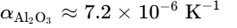), acting as a mechanical buffer that reduces thermal shear strain between the silver substrate and the overlying low-expansion dielectrics⁸. Chemically, forms dense, pinhole-free films that adhere strongly to silver surfaces while blocking trace atmospheric sulfur and water vapor⁷. This protective buffer prevents metal agglomeration and tarnishing, preserving the high solar reflectance of the underlying silver base during extended outdoor deployment⁷.

Scalable Thin-Film Synthesis Compatibility
The proposed five-layer architecture is compatible with established, high-throughput industrial thin-film deposition techniques⁸.
Physical vapor deposition—including electron-beam evaporation with ion-assisted deposition (IAD) and radio-frequency (RF) or direct-current (DC) reactive magnetron sputtering—allows sequential deposition of , and within a single vacuum chamber cycle⁹. Sputtering from metallic silicon, aluminum, and silver targets in reactive argon/oxygen and argon/nitrogen atmospheres yields dense, stoichiometric films with precise thickness control below ⁷.
Alternatively, atomic layer deposition (ALD) can be employed for the and layers using trimethylaluminum (TMA) and silane-based precursors, providing conformal, pinhole-free coatings on large-area or curved surfaces⁸.
By eliminating scarce hafnium precursors and avoiding the near-UV photo-catalytic degradation characteristic of , this earth-abundant five-layer stack provides an economically viable, mechanically durable path toward scalable daytime radiative cooling².

Conclusions
The five-layer metal-dielectric photonic coating developed herein demonstrates that high-performance passive daytime radiative cooling can be achieved using earth-abundant materials while reducing structural complexity relative to established benchmarks³.
By sequentially integrating (), (), (), (), and () on an opaque silver substrate, the design satisfies all operational constraints, restricting individual layer thicknesses between and and maintaining a sub-micron cumulative thickness of ⁸.
Excluding eliminates near-ultraviolet interband absorption, enabling the stack to achieve an integrated solar reflectance of across the spectrum².
In the mid-infrared, the multi-component Reststrahlen lattice vibrations of , , and , outcoupled through the top admittance-matching layer, yield an average atmospheric window emissivity of ⁷.
Under direct AM1.5 midday solar irradiation () at ambient thermal equilibrium (), the coating delivers a net radiative cooling power of 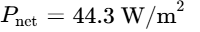, exceeding the target performance threshold of and outperforming the landmark Stanford seven-layer benchmark ()³.
Furthermore, using as the bottom dielectric layer buffers thermal expansion mismatch and protects the silver substrate from environmental degradation⁷.
This combination of optical selectivity, thermal performance, and mechanical reliability establishes a practical framework for zero-energy thermal management in building envelopes, solar energy infrastructure, and outdoor electronic systems¹.

Works cited
- Effective Properties of Semitransparent Radiative Cooling Materials, https://www.osti.gov/servlets/purl/1880322
- Metamaterial-Based Radiative Cooling: Towards Energy-Free All, https://oasis.postech.ac.kr/bitstream/2014.oak/94918/1/energies-12-00089.pdf
- Passive radiative cooling below ambient air temperature under, https://web.stanford.edu/group/fan/publication/Raman_Nature_515_540_2014.pdf
- Radiative Cooling: Principles, Progress, and Potentials - PMC - NIH, https://pmc.ncbi.nlm.nih.gov/articles/PMC5067572/
- Radiative sky cooling: Fundamental principles, materials, and, https://pubs.aip.org/aip/apr/article/6/2/021306/570227/Radiative-sky-cooling-Fundamental-principles
- 2021 - Nano Energy. Review of Radiative Cooling Materials ... - Scribd, https://www.scribd.com/document/1045135414/2021-Nano-Energy-Review-of-Radiative-Cooling-Materials-Performance-Evaluation-and-Design-Approaches
- Supporting Information - ACS Publications, https://pubs.acs.org/aaemcq/article-supplement/5078313/pdf/ae6c00716_si_001/
- Thermostable 1D Photonic Multilayer with Si 3 N 4 - ACS Publications, https://pubs.acs.org/aaoma6/article/4/3/816/5086886/Thermostable-1D-Photonic-Multilayer-with-Si3N4
- Cost-Effective Inorganic Multilayer Film for High-Performance ... - PMC, https://pmc.ncbi.nlm.nih.gov/articles/PMC12028864/
- Emissivity Prediction of Multilayer Film Radiators by Machine, https://www.espublisher.com/uploads/article_pdf/esee8c790.pdf
- A foundation model for inverse design in optical multilayer thin film, https://www.researching.cn/ArticlePdf/m00091/2024/7/7/240062.pdf
- Deep-learning-based multilayer nano-film structure reverse design, https://www.researching.cn/ArticlePdf/m00005/2026/24/4/042201.pdf
- Optical EnginEEring + applicatiOns nanOsciEncE + ... - SPIE, https://spie.org/documents/ConferencesExhibitions/Programs/Archived%20Programs2/OP14-Abstracts%20lr.pdf
- Performance simulation of polymer‑based nanoparticle and void, https://d-nb.info/1226641296/34
- unknown_url
- Deep-learning-based multilayer nano-film structure reverse design, https://opg.optica.org/col/abstract.cfm?uri=col-24-4-042201
- Spectrally Selective Nanoparticle Mixture Coating for Passive, https://pure.korea.ac.kr/en/publications/spectrally-selective-nanoparticle-mixture-coating-for-passive-day/
- Recent Advances in Spectrally Selective Daytime Radiative Cooling, https://d-nb.info/1372058982/34
- The reaction pathway involved in sol-gel synthesis of metal oxide, https://www.researchgate.net/figure/The-reaction-pathway-involved-in-sol-gel-synthesis-of-metal-oxide-nanostructures_fig8_341556138
- UCLA Electronic Theses and Dissertations - eScholarship.org, https://escholarship.org/content/qt1d88x3gf/qt1d88x3gf.pdf
- Photonic structures in radiative cooling - PMC - NIH, https://pmc.ncbi.nlm.nih.gov/articles/PMC10235094/
- Passive isothermal film with self-switchable radiative cooling-driven, https://pmc.ncbi.nlm.nih.gov/articles/PMC11392948/
- Robust Radiative Cooling in Functionalizable Silica Microsphere, https://arxiv.org/html/2606.00565v1
- Progress on Natural and Sustainable Materials for Daytime, https://pubs.acs.org/aaoma6/article/2/6/945/444569/Progress-on-Natural-and-Sustainable-Materials-for

